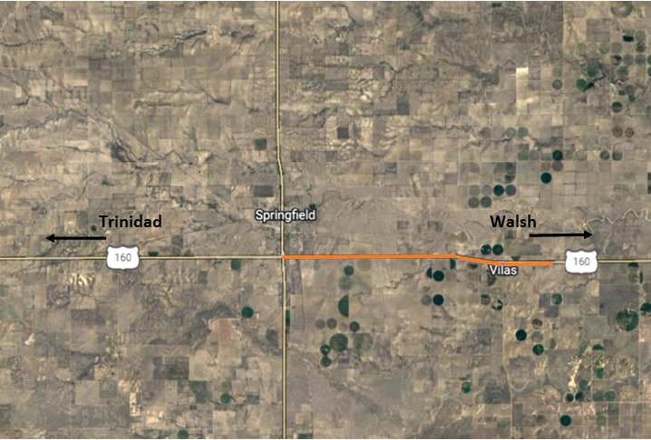
US 160 in East of Springfield

What Work is Being Done?

APC Southern Construction will begin work on US Highway 160 in Baca County. Crews will be resurfacing the roadway both eastbound and westbound, as well as making culvert improvements. Additionally, crews will be placing new shoulder material, guardrail, reseeding, mailbox replacement, fencing and high visibility striping will be done prior to project completion. A 12-foot width restriction is in place for oversize loads from Monday thru Friday, 7:00 AM to 7:00 PM. Speed reduction can be expected down to 50mph as they approach the work area and then a further reduction to 40mph in the immediate work zone, due to alternating single lane closures. Expect up to 10 minute traffic delays. These closures and delays of US 160 will be in effect between April, 2022 and July 2022.

Why is the work being completed?

This project is part of CDOT’s “Whole System. Whole Safety.” initiative aimed at enhancing safety for Colorado’s traveling public. Once the resurfacing work is completed, drivers will find a smoother roadway surface with new guardrail, new signage, high visibility markings and stabilized shoulders. These enhancements will make the highway safer for residents, visitors and commercial truck traffic.

When will crews be working?
Work will take place during daylight hours, 7am to 7pm, Monday through Friday. Night work and weekend work are not anticipated at this time.

Travel Impacts

Alternating single lane closures on US 160 between MP 464.4 and MP 475.94 and on 4miles of CO 100 between MP 0.0 and 0.4

Width restrictions of 12 feet will be in place Monday thru Friday, 7:00 AM to 7:00 PM within the project boundary.
- Flagging personnel be on sight to direct travelers as the speed limit will be reduced to 40 mph during working hours.

Project Contact Information
- Project Phone Line - (719) 600-1345
- Project email - jlopez@apc.us.com
- Project web site - https://www.codot.gov/projects/us160-co100-resurfacing-baca-county
- Sign up for weekly project updates - Please log onto the project web site and fill out the right-side form to “Subscribe to Project Updates.”

For information on road work and travel conditions visit COTrip.org, sign up for travel alerts at Alerts, or call 511. Updates are also available via Twitter @coloradodot and CDOT’s Facebook page at Facebook.com/coloradodot.

